Reports Available in Recruit
School Guidance

There are a number of standard reports that can be accessed in Recruit by clicking on the Reports tab in the menu bar at the top of the screen.
When you run a report in Recruit it is always a 2 stage process. You initially enter the search criteria which produces a list of relevant job adverts. You are then required to either select all job adverts or select one or a number of job adverts. Once run the report will be limited to the job adverts selected.
Some reports are located by clicking the reports tab and others by clicking on the export option. For reports located on the reports tab the results will appear on the webpage (you will be given the option to export and save) whereas those run from the exports tab the results will appear in a downloaded file.
These reports will only provide results for your school, reporting on applications received for a job advert. You will not be able to report on candidates shortlisted or appointed as this information is not entered into Recruit.
The information you will need to enter in each report varies depending on the output required. You are often required to enter the dates the report should cover or the stage to be reported on (eg Processing Applications) and once entered you need to click on the search button.
In most instances the report brings back a number of items (often a list of job advert reference numbers) and you are then required to select which items you require in the report and will then need to click on ‘view selected’.

In some instances you may then be required to click on view report.
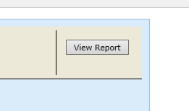
To view the full details of the report on the webpage click into the body of the report and scroll across the page.
To close a report and go back to the list of reports you need to click on the red .
Please note that a number of the standard reports available in Recruit have been developed for use by other organisations or by the Shared Services Centre and do not provide any useful information for schools when run – these reports display in Recruit but are not listed below.
Report name | Description
Applicants | Provides an alphabetical list of applicants by job reference (eg JOB/18/00345), stating whether the application was online or offline along with the date applied. Only one job reference should either be entered or selected.
Basic Job details (export) | Returns a list of jobs with associated job details. You can filter using a number of fields for example the job’s title or the appointment type – permanent or fixed term.
Diversity New | Provides anonymous equalities data by application stage. After undertaking the initial search to view the report an application stage will need to be selected.  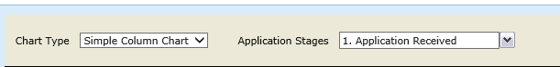
Media details [export] | Provides a list of jobs, applicant IDs and where the applicant heard about the job advert (to fully view the report you will need to scroll across).
Standard summary | Provides a count of jobs grouped by appointment type, occupational group or by job term. After undertaking the initial search to view the report you will need to select an option from the grouping drop down.  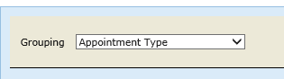
Standard summary full | Provides a list of jobs, displaying job title, job stage, job assigned to, along with the number of online and offline applications received. The report can group jobs by appointment type, occupational group or job term.
Applicant Activity (export tab) | Produces an export list (csv format) of job, applicant, date of application, applicant stage, date moved to that stage.
Campaign results (export tab) | Produces an export list (csv) of job creation date, insert and closing dates, number of applications received, number of incomplete applications and the date the job offer was made

If you require any help please call the Advertising Team on 01629 01629 535118 Option 1

