School Guidance
Setting up your access to Recruit

Access to Recruit is generated when you send in your first advert to appear on the Jobs Derbyshire website.

Your access will enable you to;

- Preview your draft advert
- View applications for your job, both online and offline
- Share job applications with other panel members.

Setting up your Recruit access using the system generated email

- You will receive an email once your account has been created in recruit. The email provides a link to Recruit which will take you to the system login page.

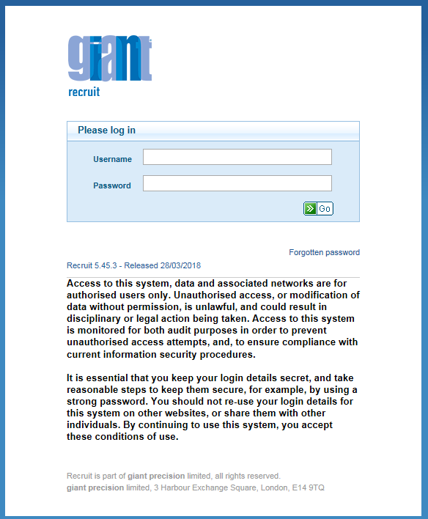

- You do not need to enter your user name or password on this screen but just click on the ‘Forgotten password’ link’.

- This link will take you to this screen in which you need to enter your email address and then click Go.

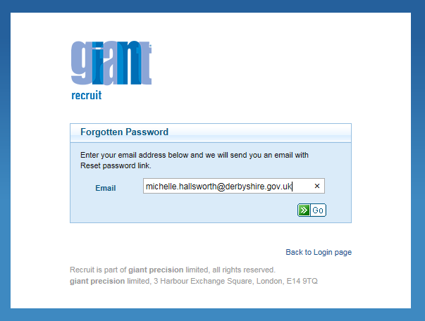

- You will then receive an email with a reset password link. The email also provides your username. Please note your username is your payroll number/SAP logon not your network logon which for some users can be different.

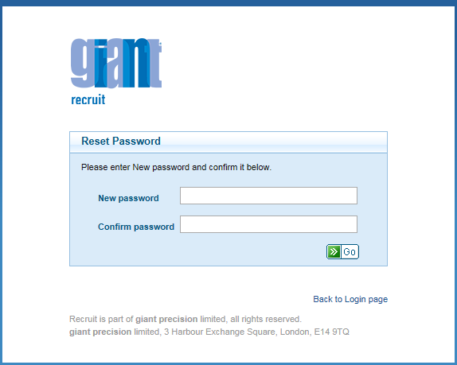

- You then need to create a password. Your password must be between 8 and 30 characters long and must contain lowercase character, uppercase character, numeric character and special character (e.g. £, $, *, %, &). Once you have entered your password and confirmed it click ‘Go’ and you will be taken to the Recruit login screen where you will be required to enter both your username and password to gain access to Recruit.

Future Access

To access the system in future you will need to click on the following link: https://derbyshire.recruitsaas.com/Login.aspx

You will need to retain this link so that:
- you can access the system to create a start the recruitment process,
- update details of your recruitment(s)
- track progress of your recruitment(s)

You can access the link easily later by:
- Adding it to your internet favourites
- Creating a shortcut on your desktop

Creating a Shortcut on Your Desktop
You need to have recruit open so use this link to access it https://derbyshire.recruitsaas.com/Dashboard.aspx. The link displays in top left hand corner of the screen.

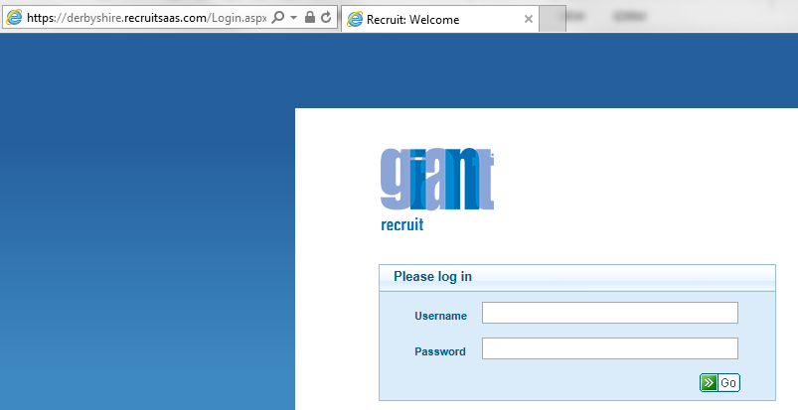

Highlight the link: https://derbyshire.recruitsaas.com/Login.aspx If you click in the link will then hightlight it and appear as below.

Right click on the mouse and select ‘copy’.

Navigate to the desktop on your PC/Laptop.

An easy way to do this is to use the button at the bottom right handside of your screen. Click here and everything you have open will minimise.
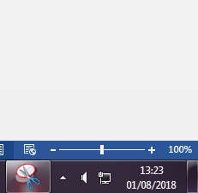

Right click on the mouse to display on the following menu:

Scroll to ‘New’, the following menu will appear:

Select ‘Shortcut’ and the screen below will display:

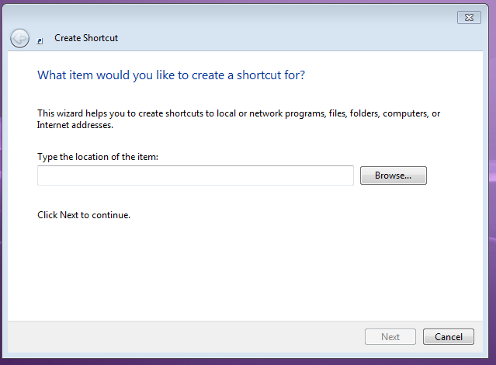
Click into the box and right click the mouse and select ‘paste’, then click on ‘Next’
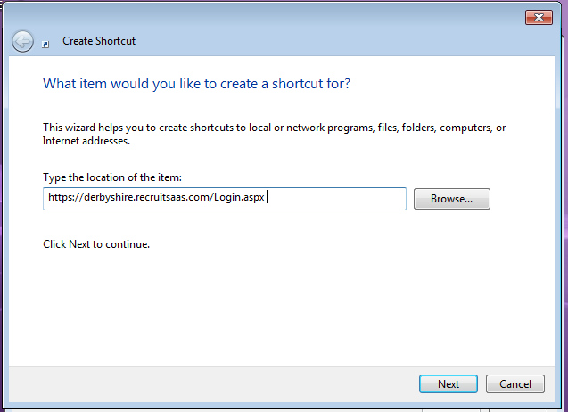
When the following box appears, enter ‘Recruit Login’ into the field ‘Type a name for this shortcut’ and click ‘Finish’.
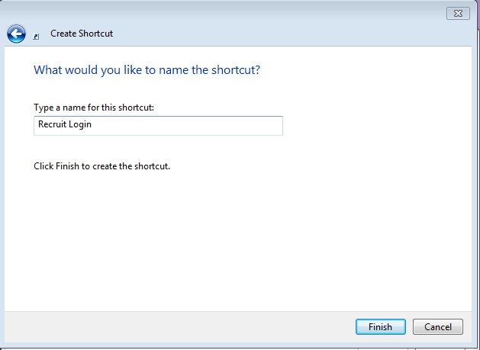

Your new Recruit Login shortcut will appear on the desktop of your PC/Laptop.
