Viewing your draft job advert
Schools

After you have sent you Advert Request Form to the Advertising Team in the Shared Services Centre and it has been processed you will receive an email that informs you that the jobs is ready for you to review prior to being made live.
In this email, there is a link to your job. Please ensure you are logged into Recruit before clicking on the link. The link will then take you straight to the job in Recruit.

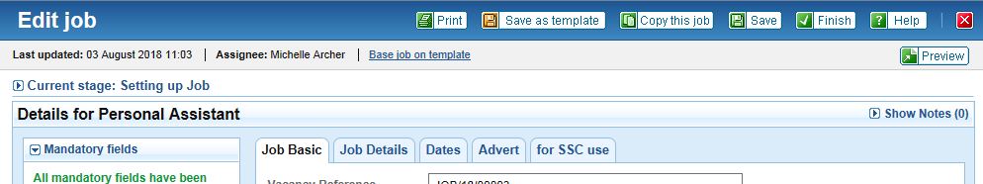

You then need to click on the preview button and you will then be able to view your job as it will appear on the Jobs Derbyshire webpages.

If you are happy with the advert or if you need any amendments making this needs to be clicking on the email link in the advert and sending your response.

If you do not respond within 2 working days your advert will be made live by default.

